**ST. JOHNS COUNTY Conservatives**

10/22/2024

**\*\*\*\*\*\*\*\*Vote Early: In Person\*\*\*\*\*\*\*\***

*Early voting began yesterday, Monday 10/21 and so far, the plan to vote early and in person is working. There are several reasons for voting early, in person. It allows the campaigns to “chase” the ballot. This means that campaigns can focus on the voters who have not gotten to the polls yet and they don’t have to waste their time with voters who have already voted. I know many will insist on waiting until Election Day and of course that is your prerogative, but voting early also avoids any mishaps that would prevent you from making it to the polls on 11/5. Additionally, voting in person is the most secure means of voting at this time. Paper ballots will be in many more hands than an electronic ballot at the polls. Whether you mail your ballot (remember TWO stamps) or drop it in a Secure Ballot Intake Station (at all early voting locations) or bring it directly to the Supervisor of Elections Office, there are more opportunities for the ballot to get lost or placed in the “wrong” hands. I am very trusting and I don’t think anything nefarious would happen, but why take the chance if you don’t have to? Below you will see that after just one day of early voting, 11% of the eligible voters have already voted.*

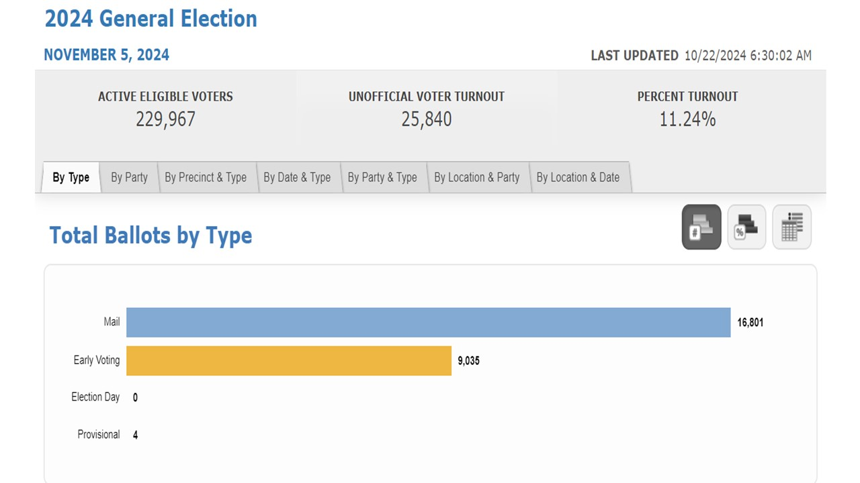

**Early Voting Locations**

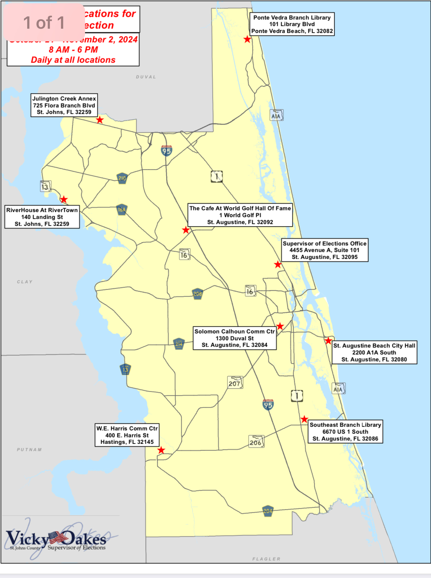

**\*\*\*\*\*\*\*\*\*\*The Ballot & Guidelines\*\*\*\*\*\*\*\*\***

**Sample Ballots**

Sample ballots have been mailed and they can also be viewed online by going to: <https://www.votesjc.gov/view-my-sample-ballot> and select “Check My Status”. Attached is a copy of my sample ballot for your reference.

**Voter Guide**

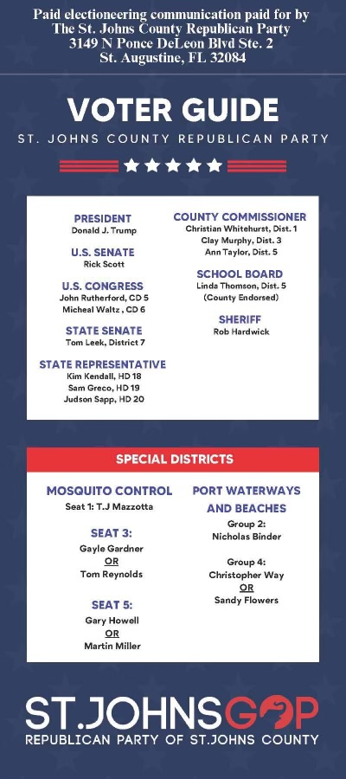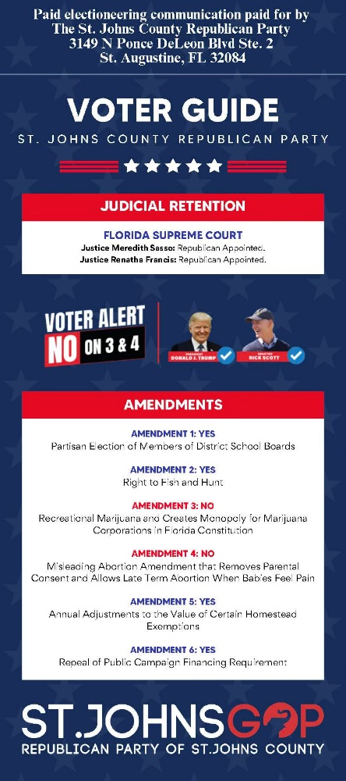

*\*We are recommending you write in the name “Ann-Marie Taylor” for the position of County Commissioner District 1. Her campaign was negatively affected by the FAKE VOTER GUIDES that were sent just prior to early voting in the primary. Ann-Marie is NOT eligible to win this race, but it will be a show of solidarity to her and a statement that we are opposed to development without infrastructure.*

**Judges Guide**

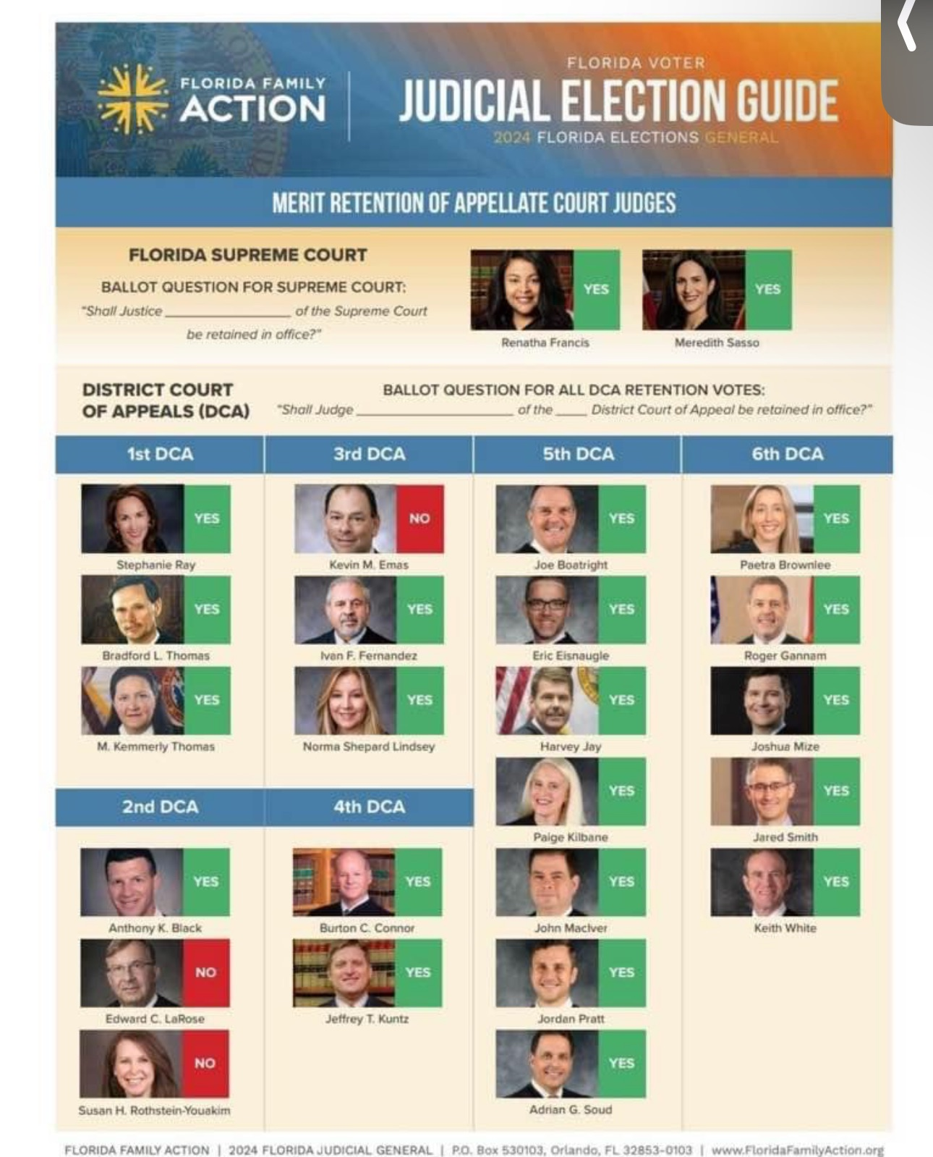

**Amendment 3 & 4 Explained**

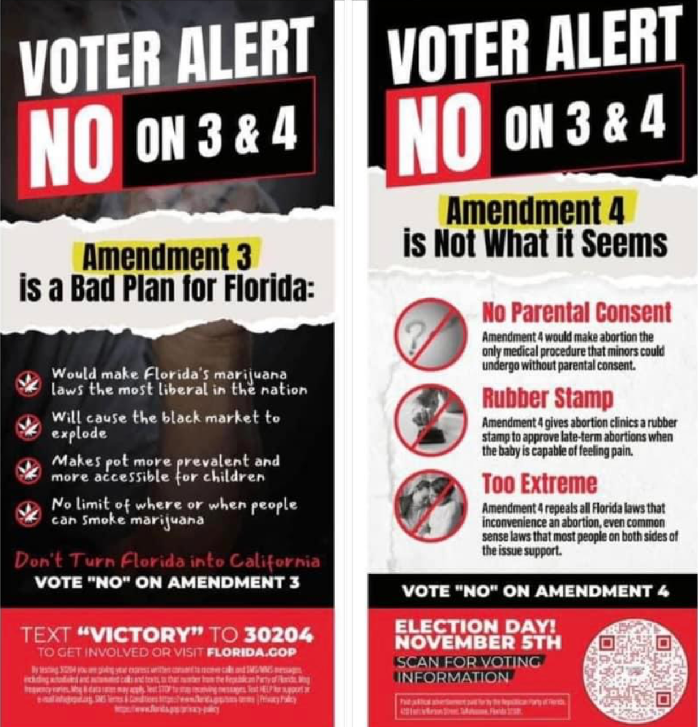

**Vote RED Down the Ballot**

There may be candidates you are not warm and fuzzy about, but we have a greater chance of finally getting things done nationally if we vote RED down the ballot. If we have control of the Senate and the House of Representatives in addition to the White House, much more can be accomplished. If we lose the Senate and/or the House, there are chances for more bogus impeachment accusations and obstruction to the conservative/republican agenda.

**Flag Waving, Sign Waving, Golf Cart Parades**

This Saturday, 10/26 and next Saturday, 11/2, we will be hosting a Sign & Flag Waving event from 10:00 am until noon. We will meet in front of Starbucks in Nocatee. Please, park your vehicle in the general parking lot and leave the spaces at Starbucks for customers. We will have Trump signs and flags if you need them or you can bring your own. There will be signs for local candidates as well. Dress up in Trump gear and bring your family, friends and co-workers. The more the merrier. It really is a lot of fun and it helps to Get Out the Vote! We are also going to try to put together a golf cart parade for 11/2. Be looking for an Evite from me in your inbox.

**\*\*\*\*\*\*\*\*\*\*Victory Party\*\*\*\*\*\*\*\*\***

As soon as Donald J. Trump is declared the winner, we will set a date for our Victory Party. Of course, we will let you know the details as soon as they are planned.

**Upcoming Events:**

1. **St. Johns County Conservatives Meeting:** Next meeting TBD. It may be a Victory Party in place of our regular monthly meeting
2. **Flag/Sign Waving:** 10/26 and 11/2 from 10:00 – noon in front of Starbucks Nocatee
3. **Golf Cart Parade:** 11/2; details forthcoming
4. **District 4 Meeting:**  ThirdThursday of the month at 6:15 p.m. Location: Palm Valley Community Center. 148 Canal Blvd. Ponte Vedra Beach, FL 32082
5. **Board of County Commissioners Meetings:** First and third Tuesdays each month at 9:00 am in the County Auditorium, 500 San Sebastian View, St. Augustine, FL.
6. **St**. **Johns County School Board Meetings**: <https://www.stjohns.k12.fl.us/meeting-notices/>
7. **St Johns County Republican Executive Committee:** First Thursday of the month. [www.Stjohns.gop](http://www.Stjohns.gop)

**Check out our updated website:** [**www.stjohnscountcounservatives.org**](http://www.stjohnscountcounservatives.org)

**(Still a work in process)**

**Follow and participate in discussions on our Facebook page: https://www.facebook.com/groups/stjohnscountyconservatives**

**The Next St. Johns County Conservatives Meeting:**

**TBD**